**CI/CD FOR FLUTTER iOS APP USING GITHUB ACTIONS**

**(Self-Hosted Mac Machine Runner)**

This Document shows how to build a CI / CD Pipeline for the flutter iOS App which will generate the Distribution version of IPA file will be same published on App Store Connect (Test Flight).

Below are the required pre-requisite needed to move forward.

**Pre-Requisite:**  
  
1. Self-Hosted Runner (Mac-Machine)

2. Xcode Installed

3. Apple Development Certificate

4. Apple Distribution Certificate

5. Apple App Store Provisioning Profile for App (Required Only when Manual Signing)

6. ExportOptions.plist File (For Export Options for IPA File)

6. App Store Connect Issuer ID

7. App Store Connect API Key

8. App Store Connect API Key ID

**Step-1:** First we have to Set-Up the Required Certificates (Development and Distribution Certificates) in the Runner’s Keychain.

I have following two certificates which we’ll be required to setup or install on the Mac System on which our CI/CD jobs will be executed.

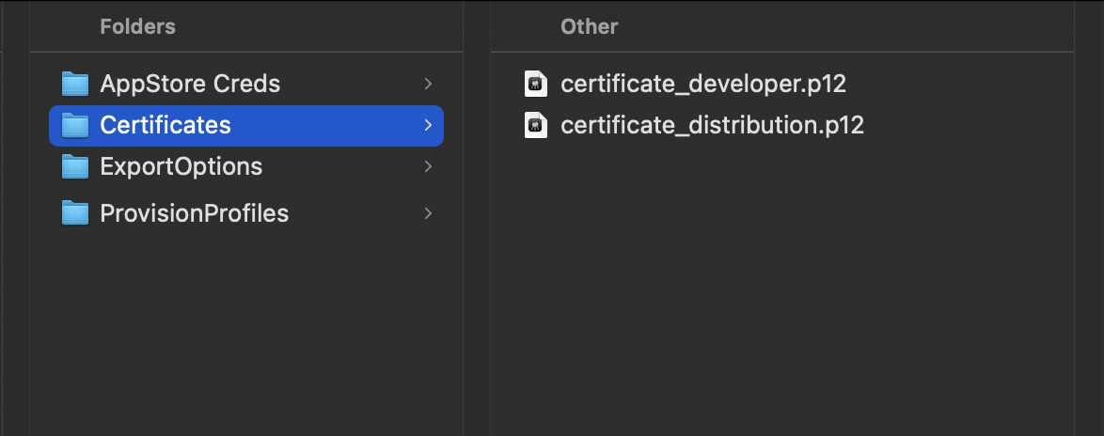

Open Keychain Access App on Mac, click on Login and you can see in **My Certificates** Tab there are no certificates installed.

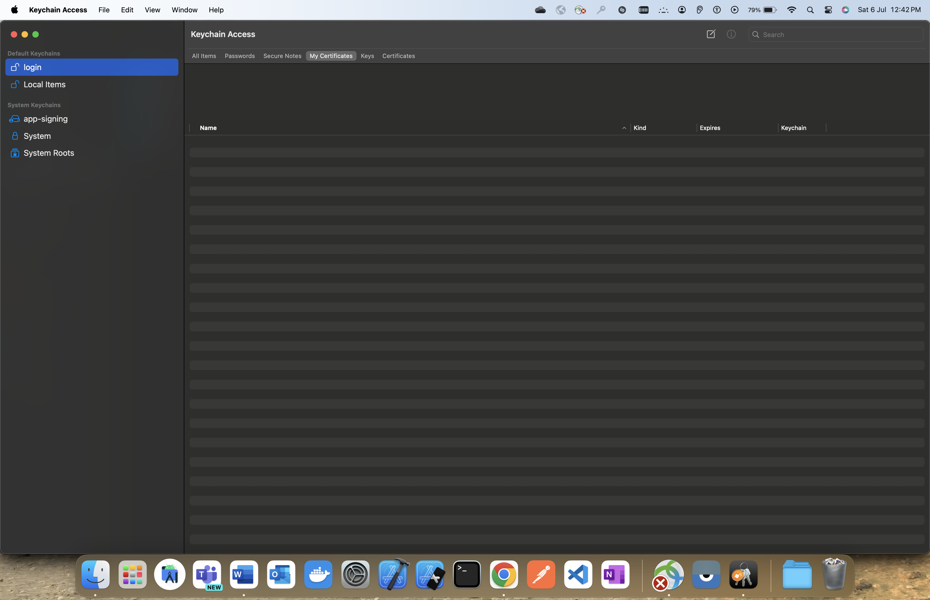

To install the above certificates double click on each certificate, password prompt will appear on the screen asking to enter the certificate password -> **Enter the Certificate Password** and click on **OK**.

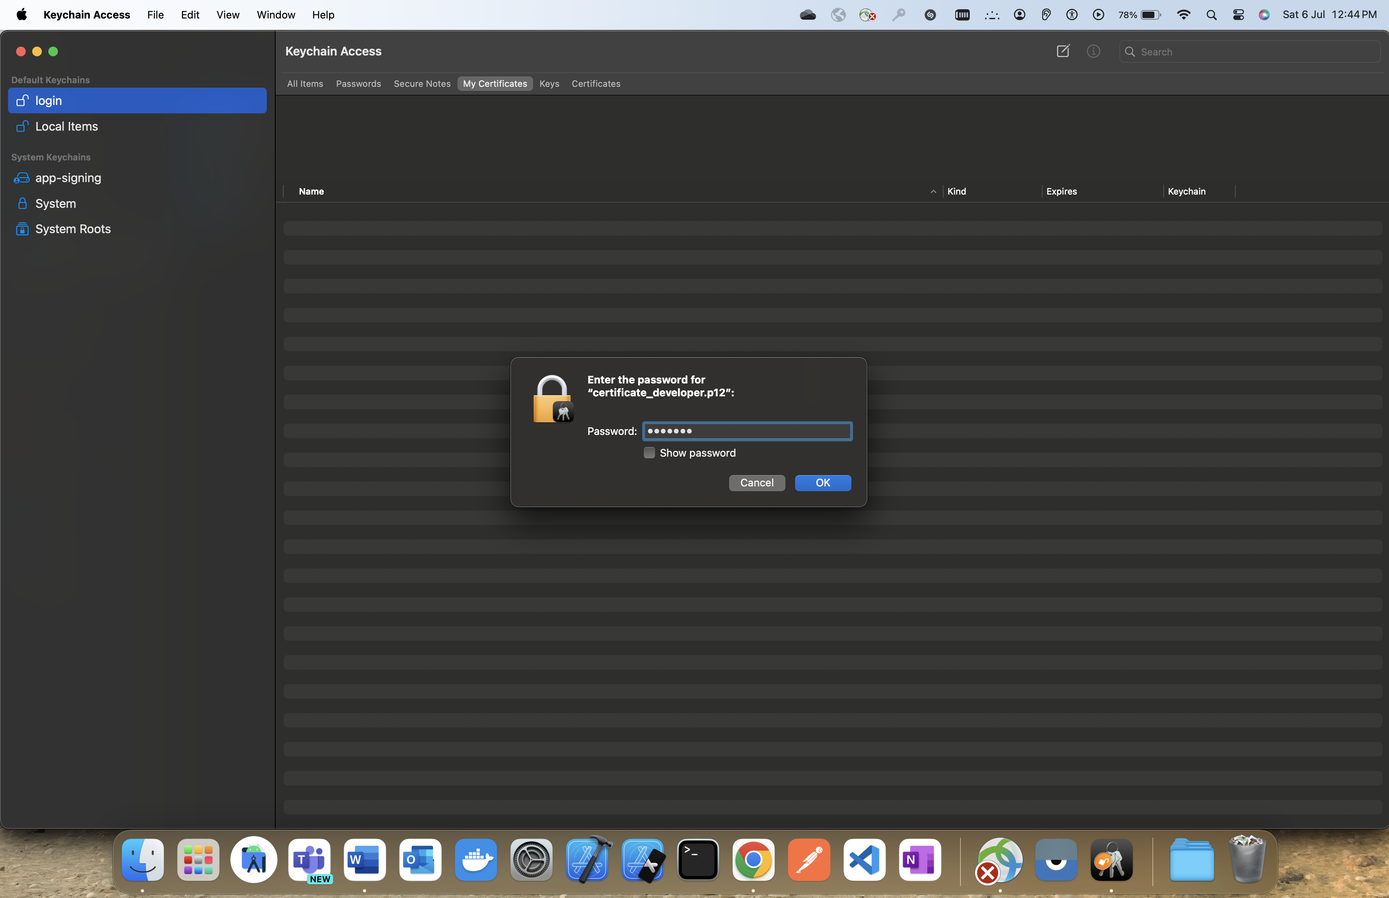

Do the same for each certificate and then you can see in the key chain both the certificates will appear .

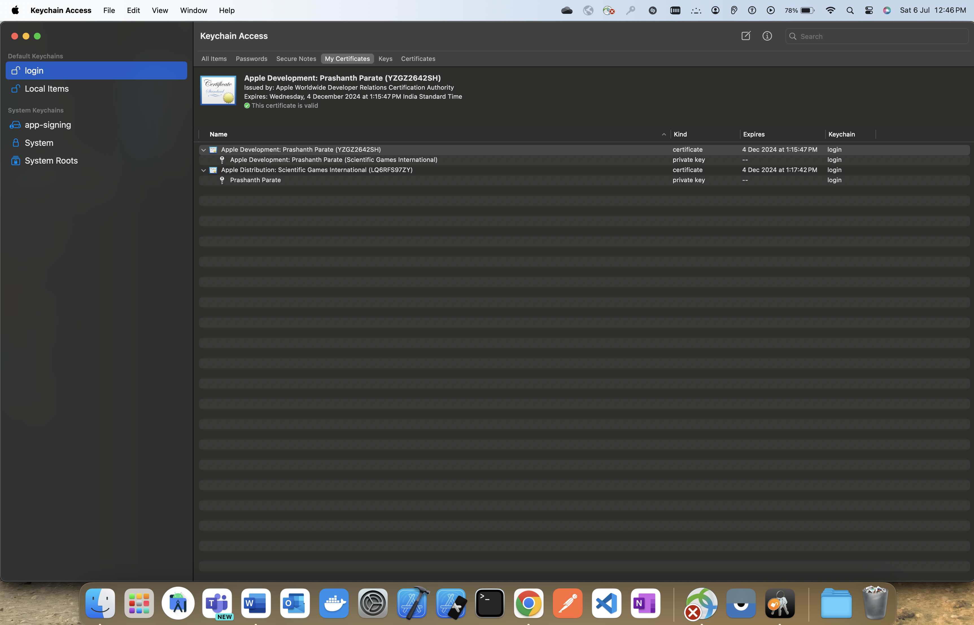

**Step-2:** Next we have to set-up the self-hosted runner machine, the workflow jobs will be executed on our self-hosted runner independent to GitHub standard runners.

Navigate to GitHub Repository -> Settings -> ( Left Tab Pane ) Actions -> Runners.

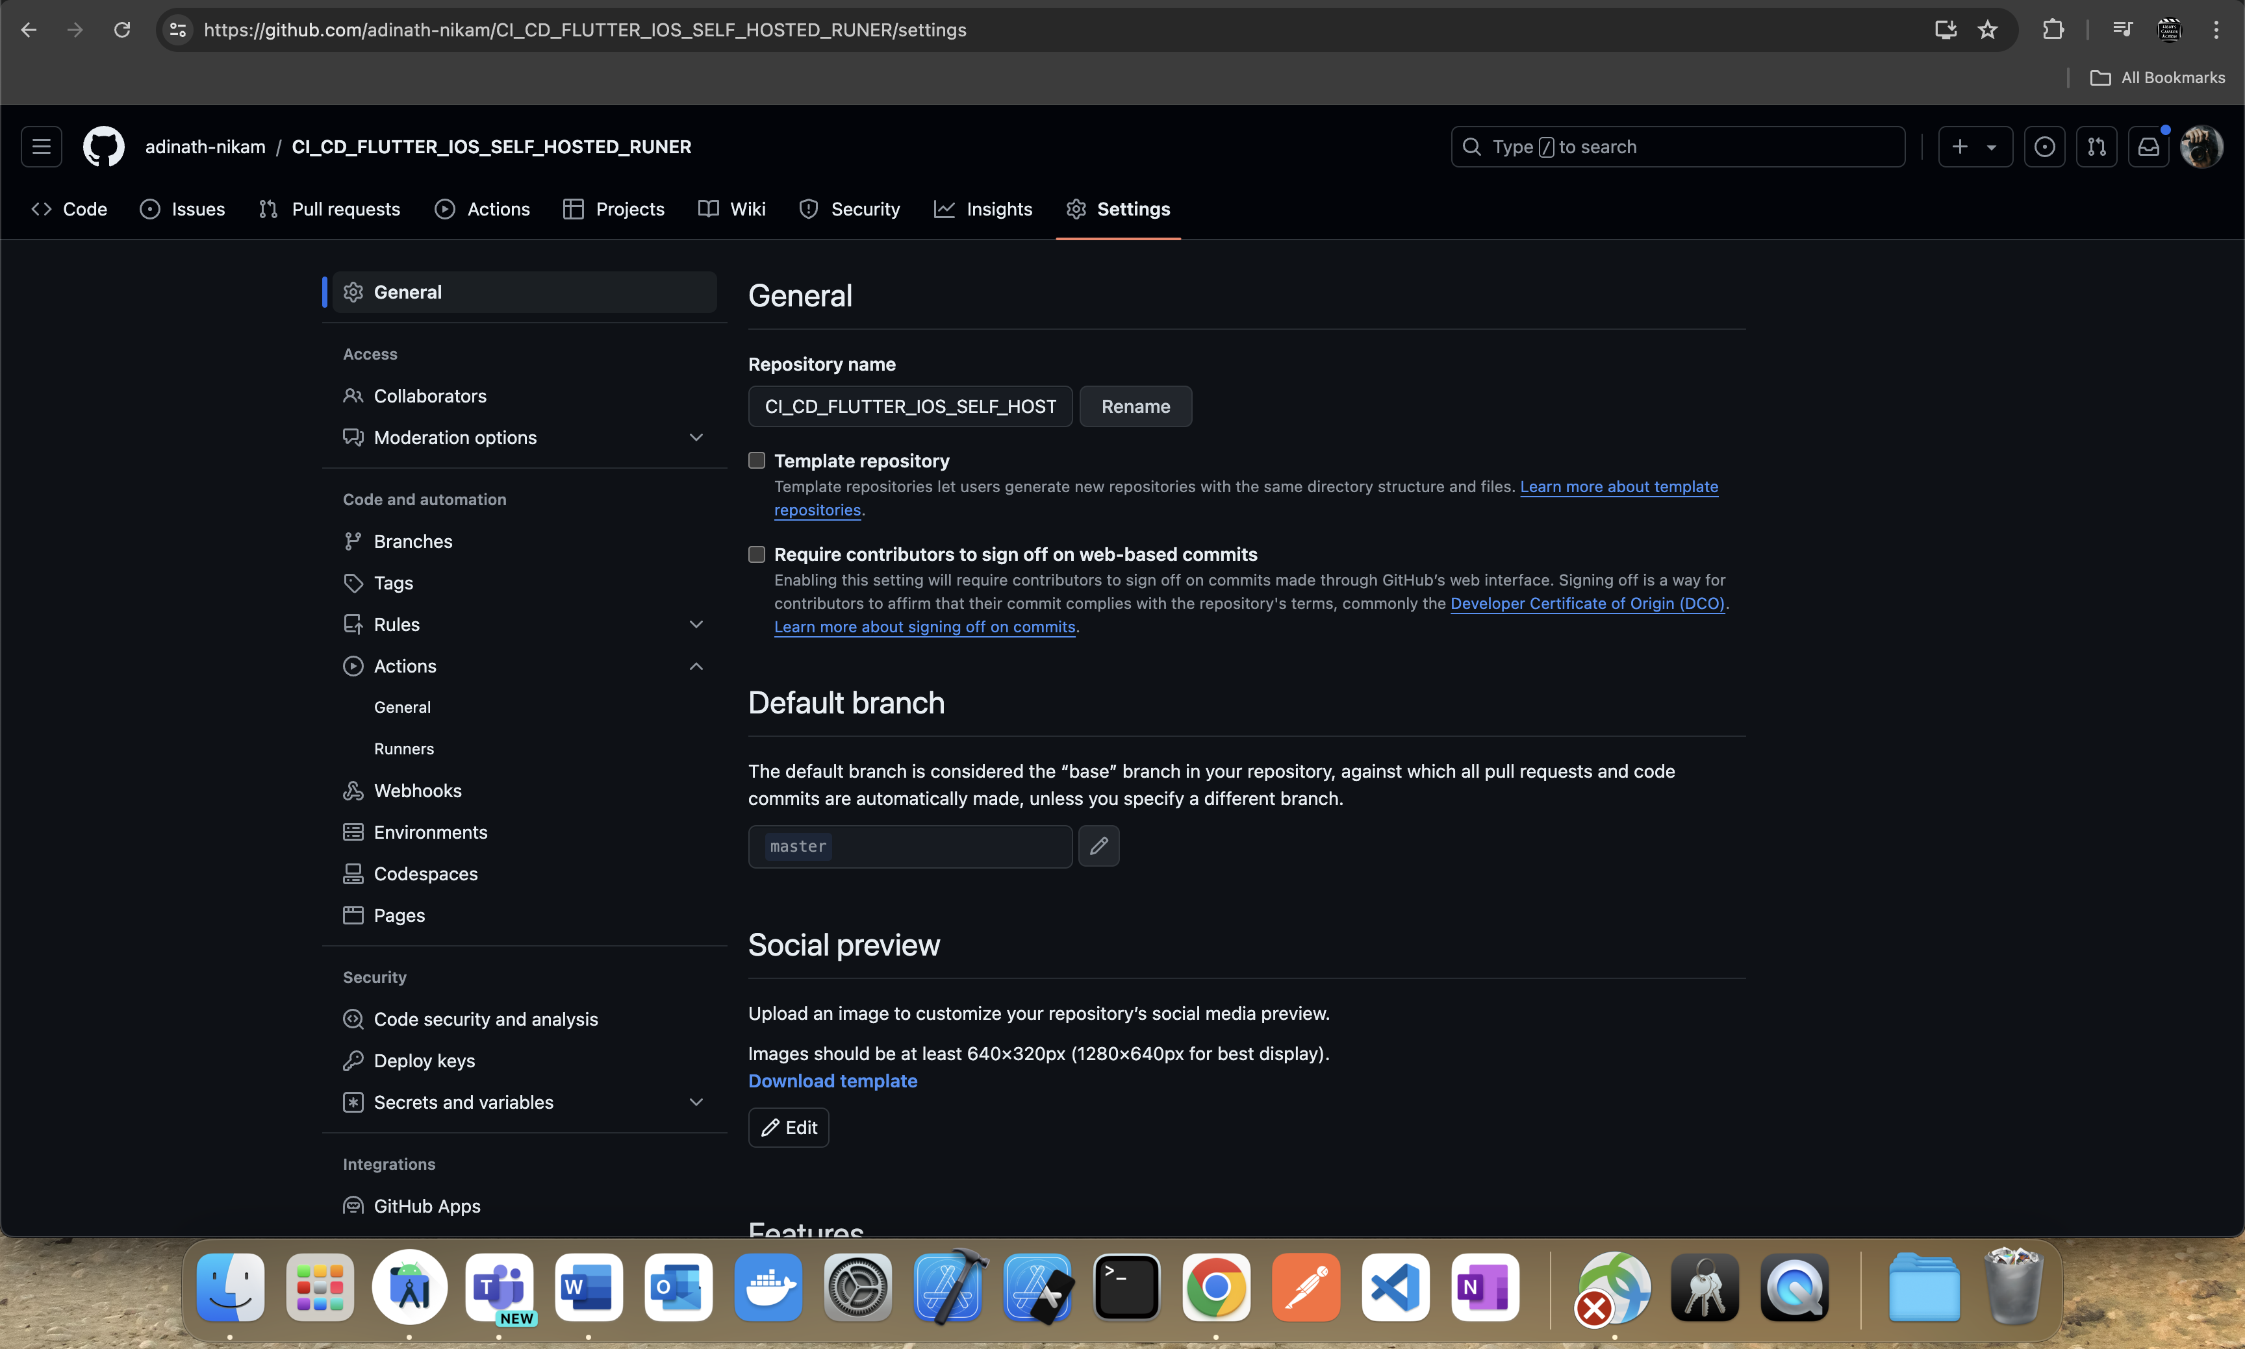

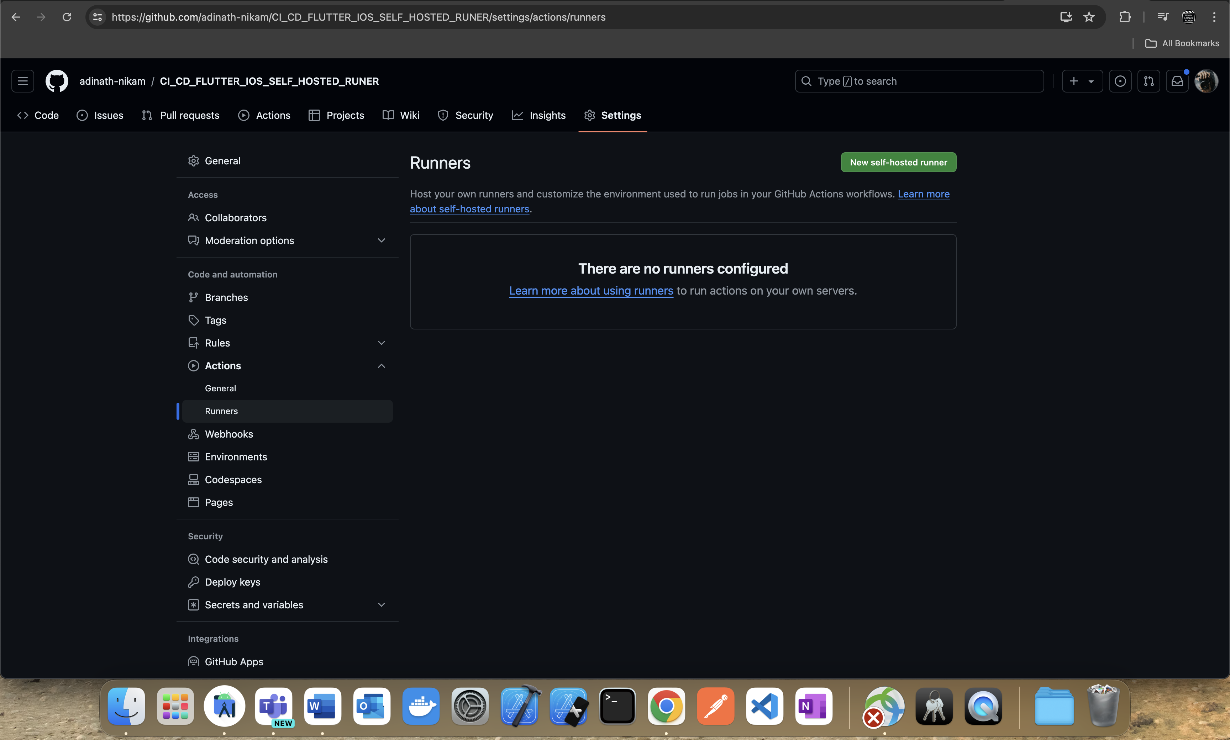

Click on “**New Self Hosted”.**

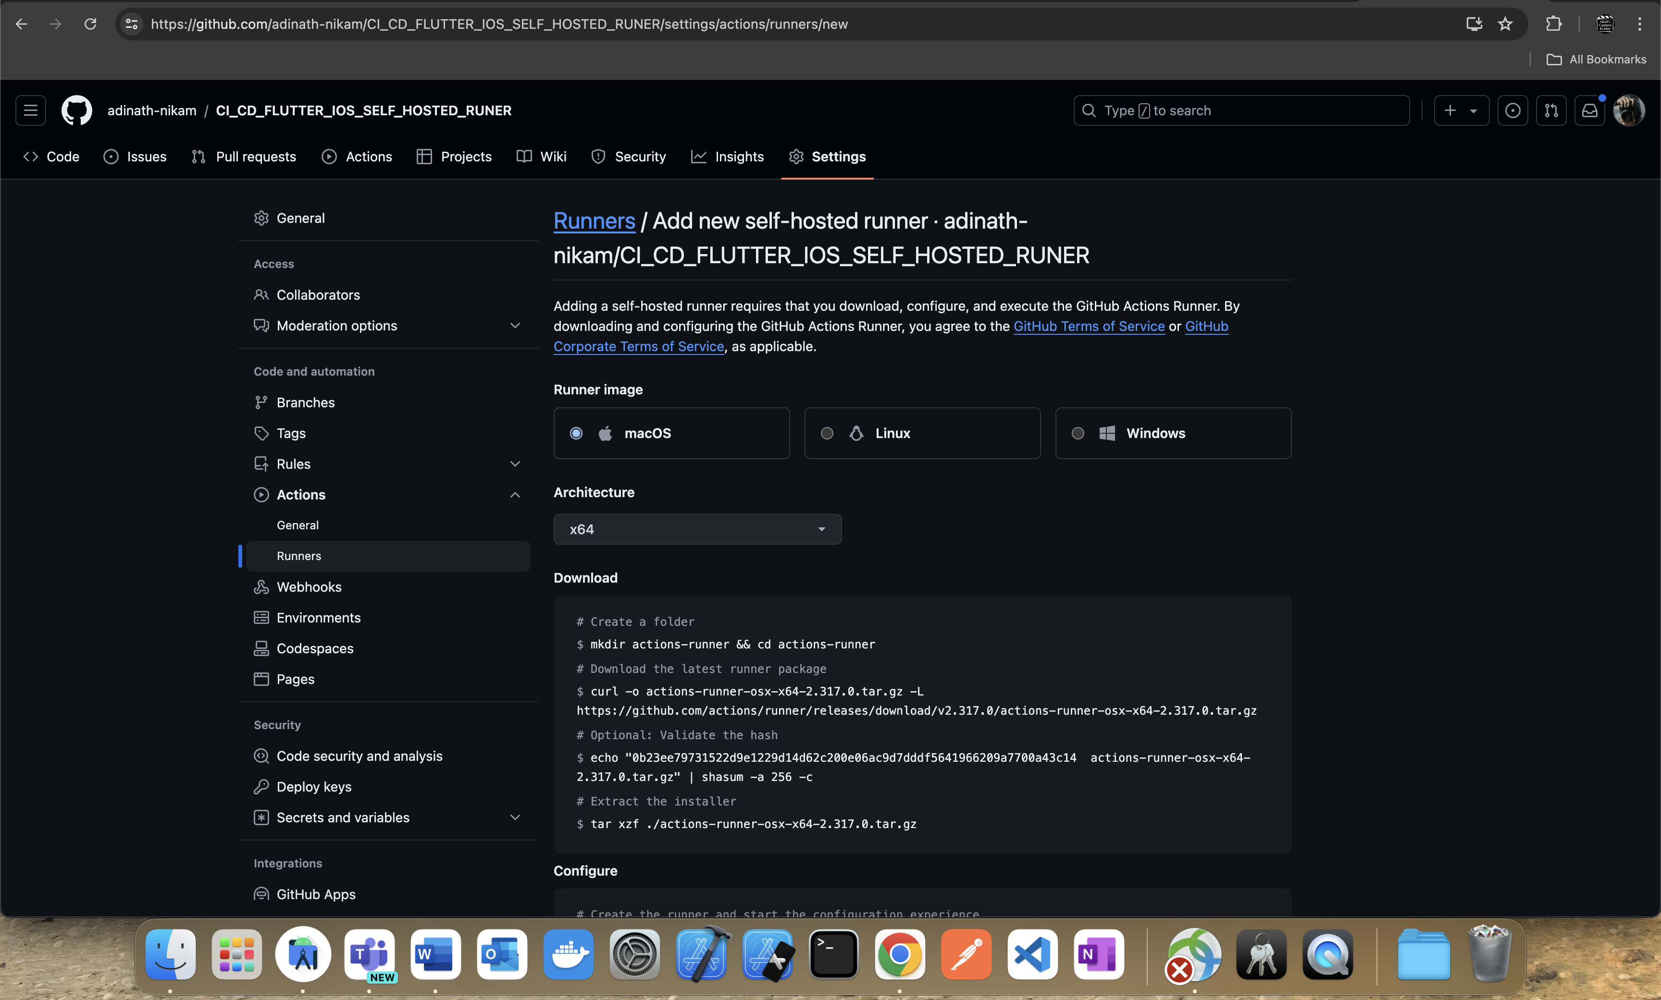

Select macOS as Runner Image as we need Mac Operating System to generate the iOS build.

Select Architecture as x64 (Default Selection).

Next Follow the Download and Configure Steps to set-up the Runner.  
  
Once Runner is Set-up open the Folder in Terminal where runner files are installed and enter the following command to Execute the Runner.  
  
**[Command] >> ./run.sh**

Now I’ll be listening to any incoming jobs…

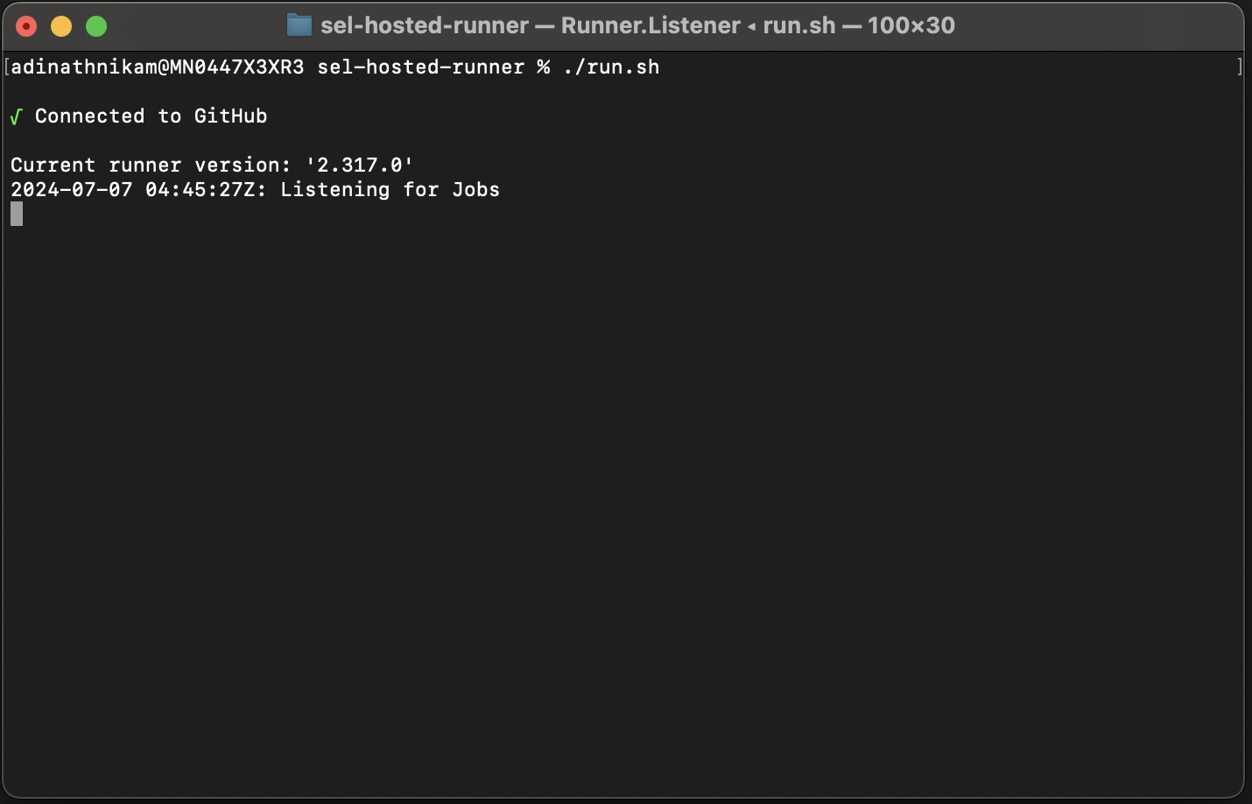

I’ve created the runner folder in local project repo it-self so it’ll get pushed along with the project files to the GitHub.\

**Step-3:** Create a GitHub Repository and Flutter Project and Push the Same to the GitHub Repository.

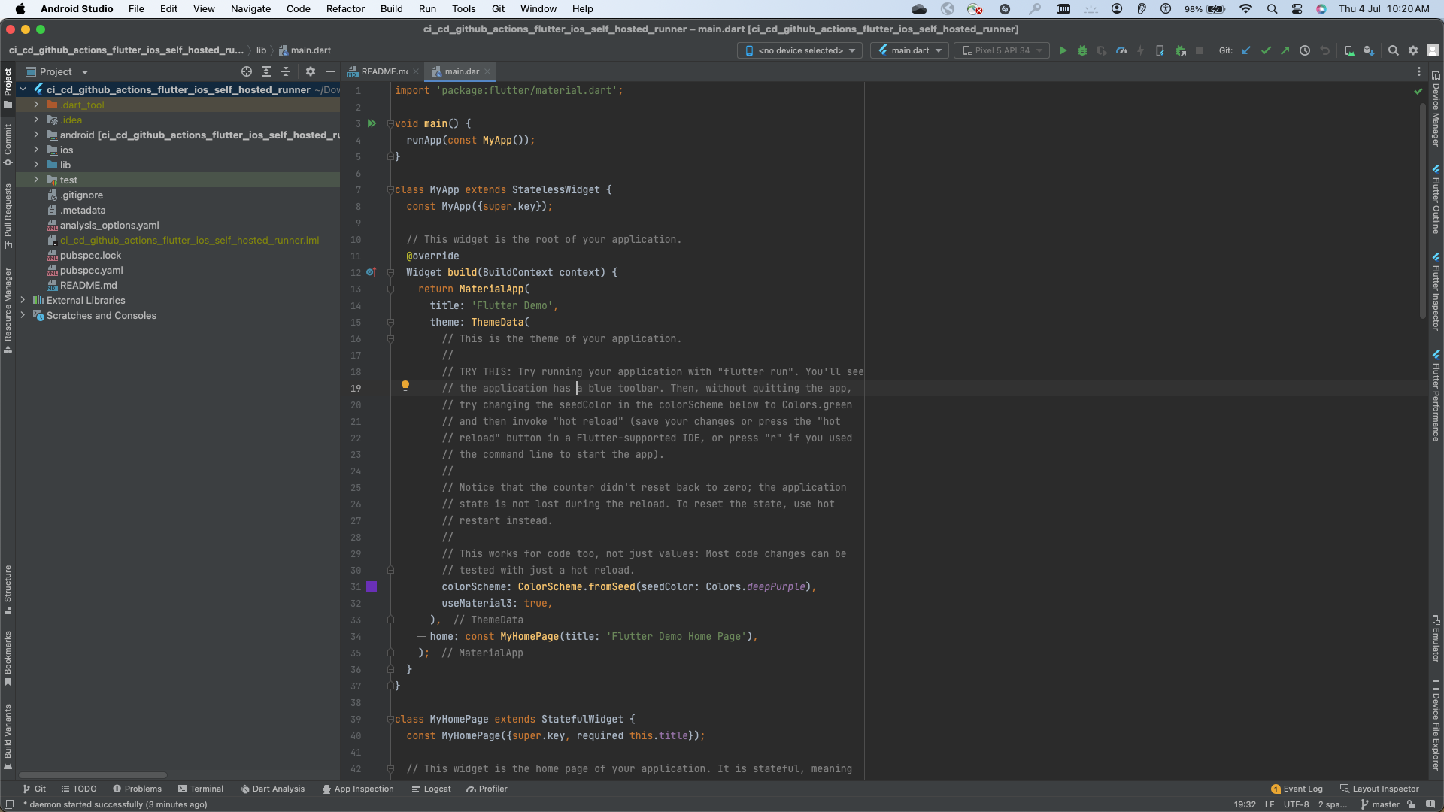

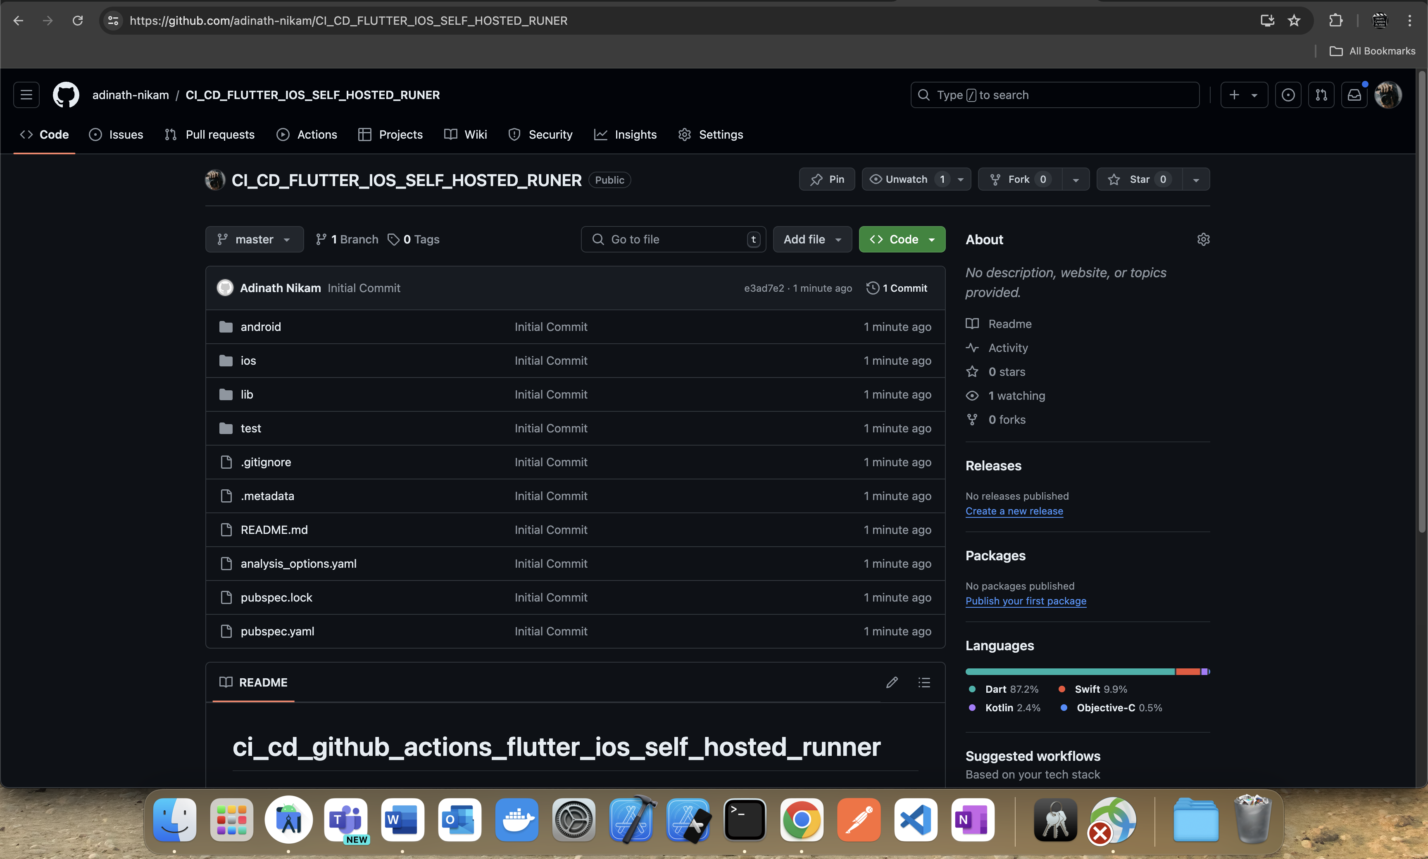

**Step-4:** we have to write the workflow script which will contain the jobs.  
  
create a following directory and files in the root of the project.  
  
**[ .github / workflows / any_file_name.yaml ]**

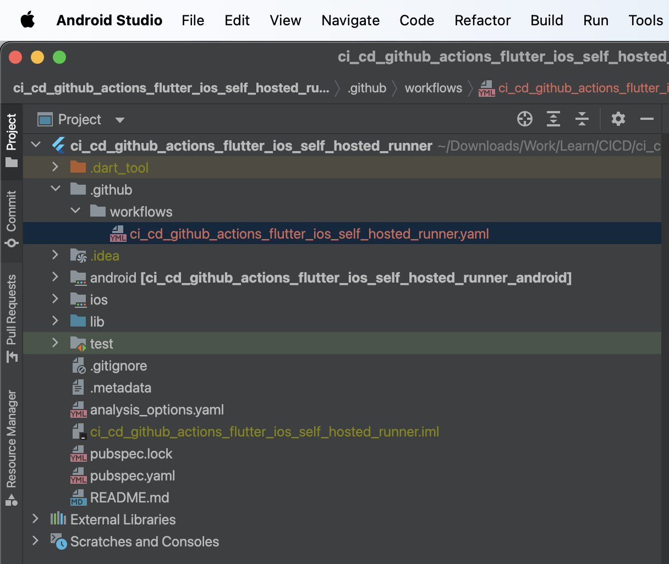

**Step-5:** Next just have to test if everything is working as expected to do that just check the local GitHub repo status and stage and commit and push to the remote repo all the new files to the GitHub repository.

**Step-6:** Put the below content to theWorkflow Script.

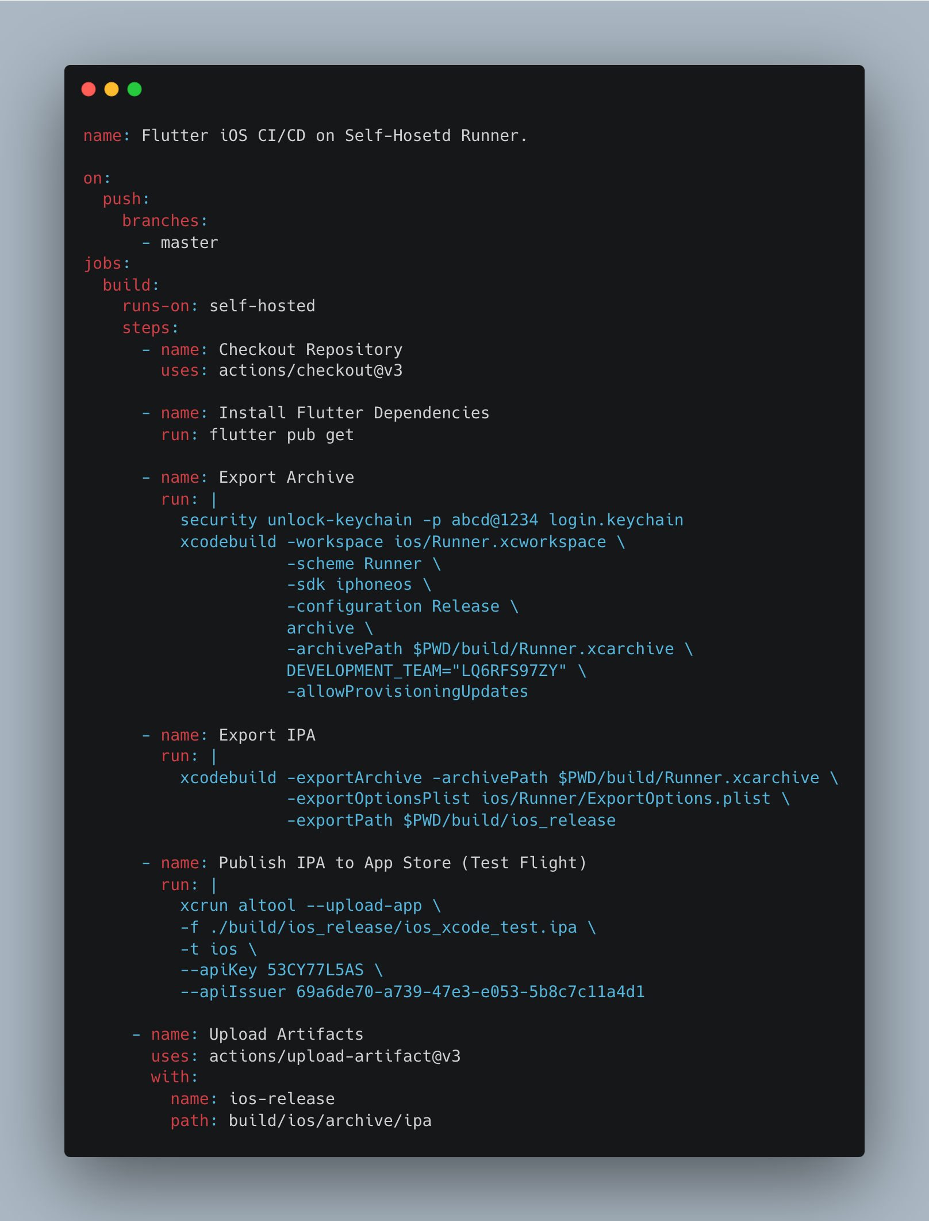

Breakdown Explanation:

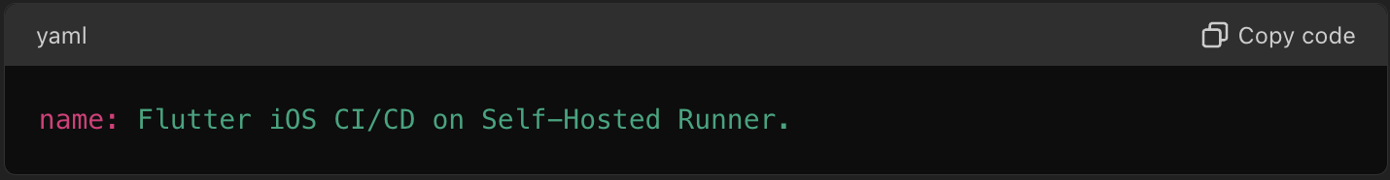

* The name of the workflow is Flutter iOS CI/CD on Self-Hosted Runner.

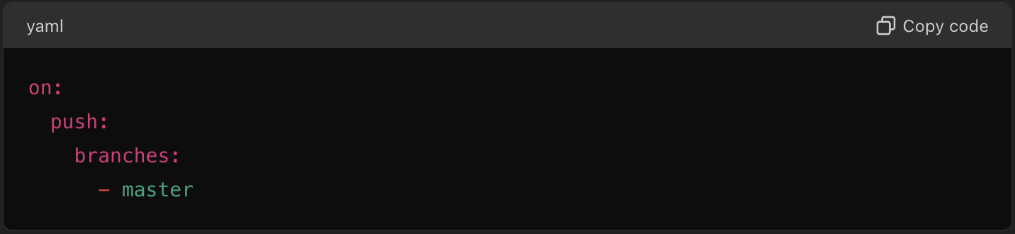

* This workflow is triggered by a push event to the master branch.

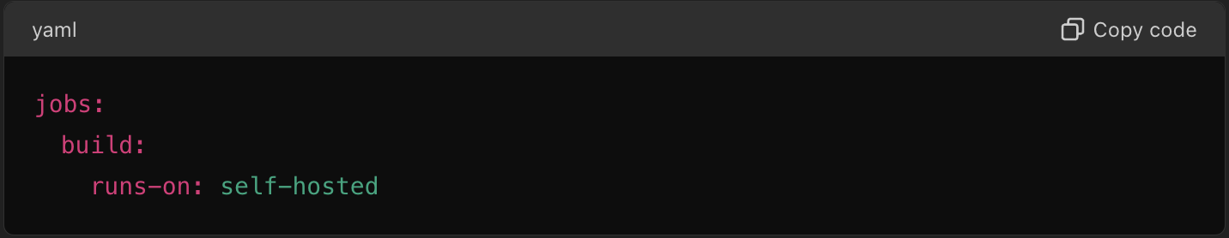

* The build job runs on a self-hosted runner.

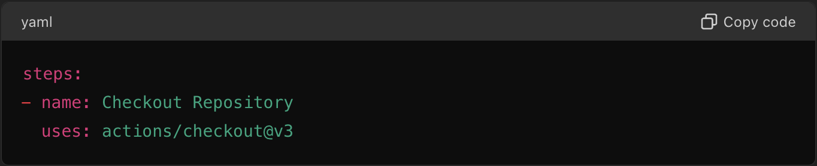

* This step checks out the repository using the actions/checkout action.

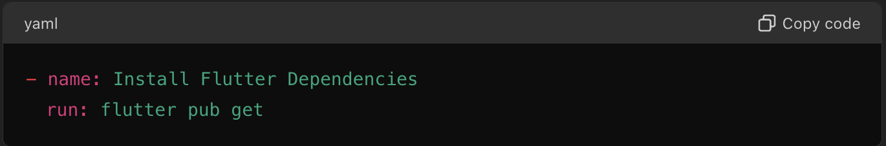

* This step installs the Flutter dependencies using flutter pub get.

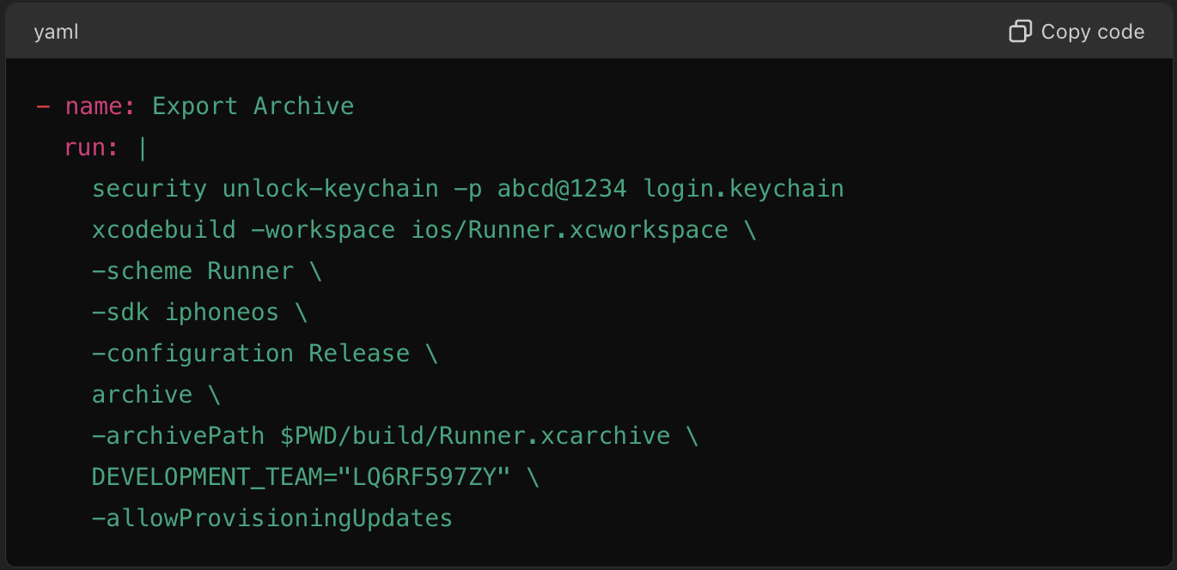

* This step unlocks the keychain and builds the iOS app archive using xcodebuild. It specifies the workspace, scheme, SDK, and configuration. It also defines the archive path and the development team.

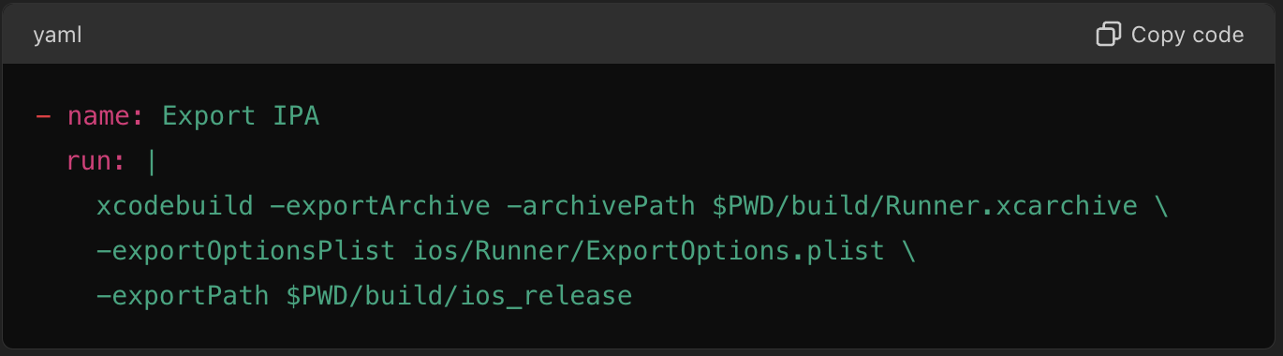

* This step exports the IPA file from the archive using xcodebuild, specifying the archive path, export options plist, and the export path.

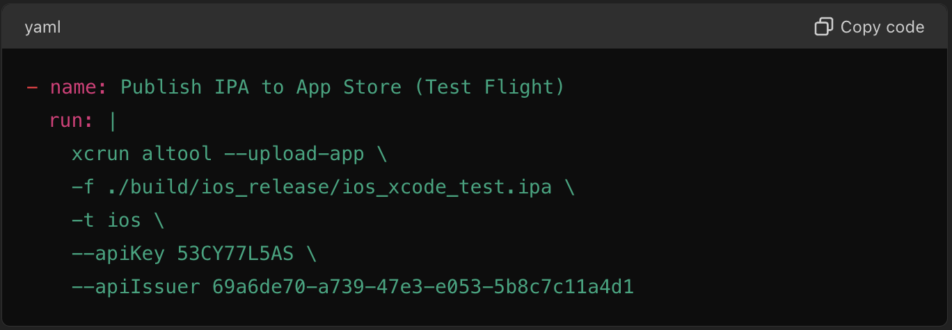

* This step uploads the IPA file to the App Store for TestFlight using xcrun altool, specifying the file path, API key, and API issuer.

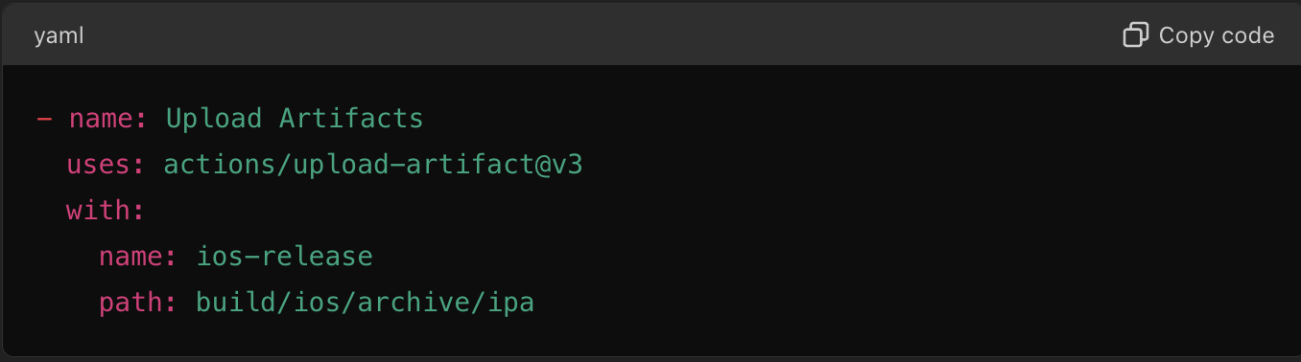

* This step uploads the generated artifacts using the actions/upload-artifact action, specifying the artifact name and path.

**Summary**

**Trigger:** The workflow runs on pushes to the master branch.

**Runner:** It uses a self-hosted runner.

**Steps:**

1. Checkout the repository.
2. Install Flutter dependencies.
3. Build the iOS app and create an archive.
4. Export the IPA file.
5. Upload the IPA file to TestFlight.
6. Upload the artifacts for later use.

**Step-7:** Next we have to change the app bundle identifier to what we have entered while creating the provisional certificates and by what the app is registered on the App Store.

In my case I have registered the app with bundle identifier as

**“com.scientificgames.cicdtestapp”**

**To make changes Navigate to -> ios/Runner.xcodeproj/project.pbxproj**

Replace -> “com.example.ciCdGithubActionsFlutterIosSelfHostedRunner”

With -> “com.scientificgames.cicdtestapp”

Everywhere wherever it appears.

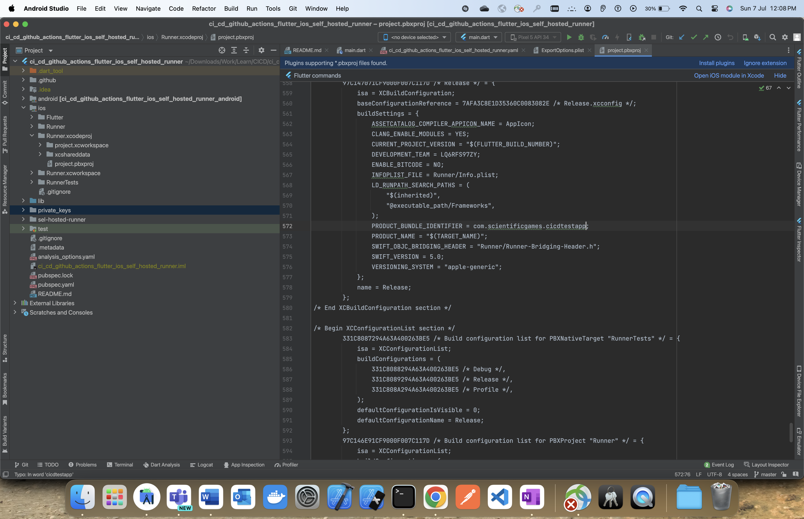

Next to publish the app at App Store, we need to place the API Key to the private_keys directory at the Root project level directory.

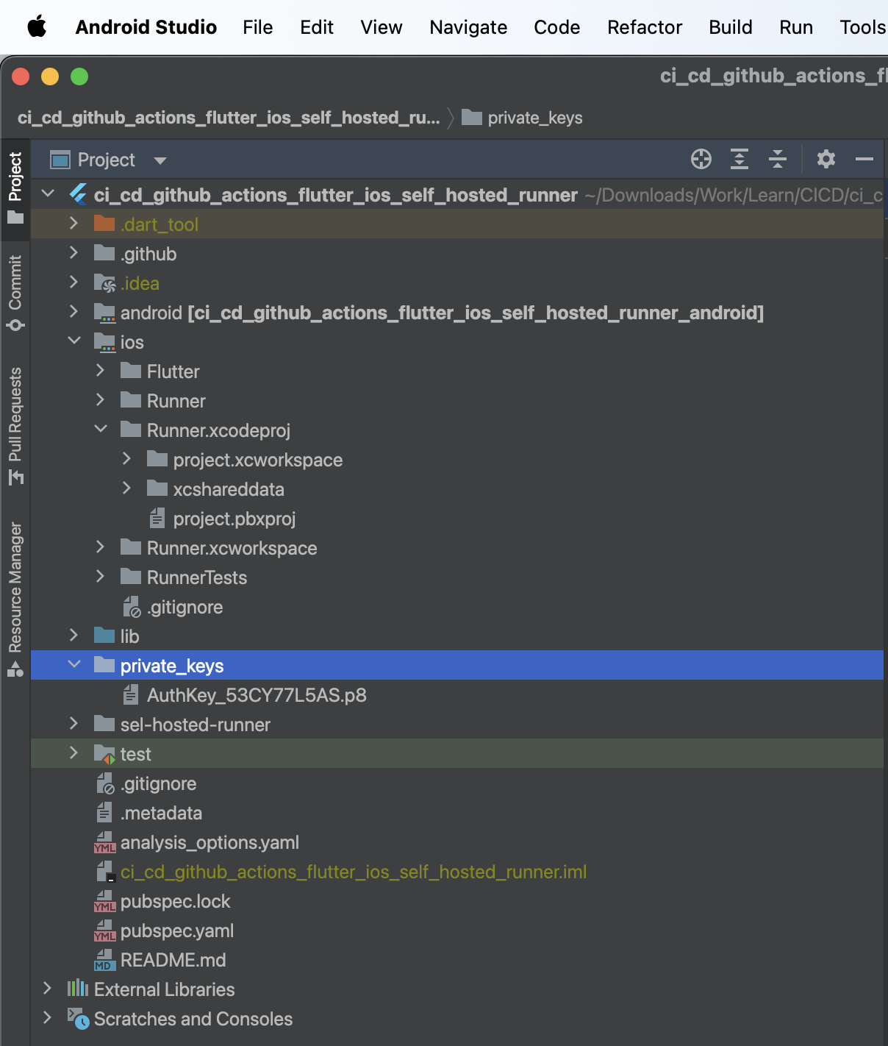

Directory Name and File Name should be strictly followed.

**Step-8:** Next, we have to define the Export Options for the IPA file for that we have to create a ExportOptions.plist file which will hold the Export Options for IPA File.  
  
I’ll be Placing the ExportOptions.plist -> ios/Runner Directory.

Put the below Contents to the same ExportOptions.plist  
  
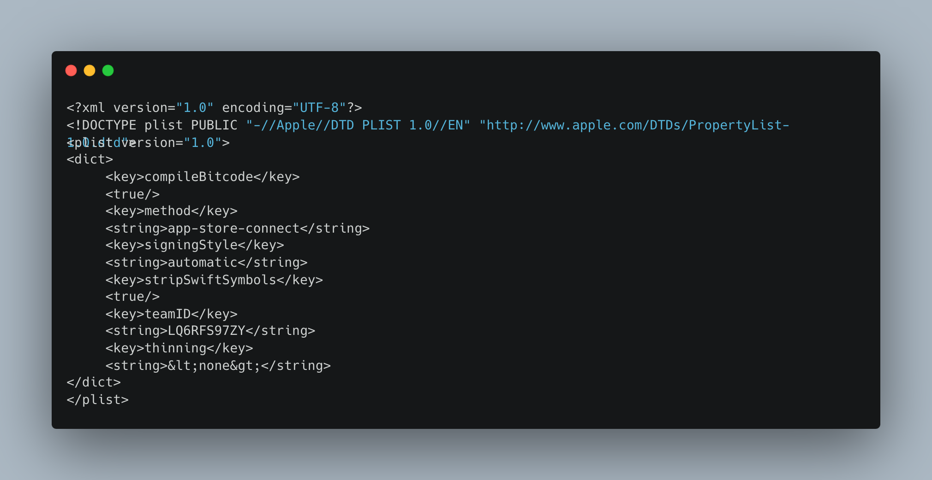

ExportOptions.plist Breakdown:  
  
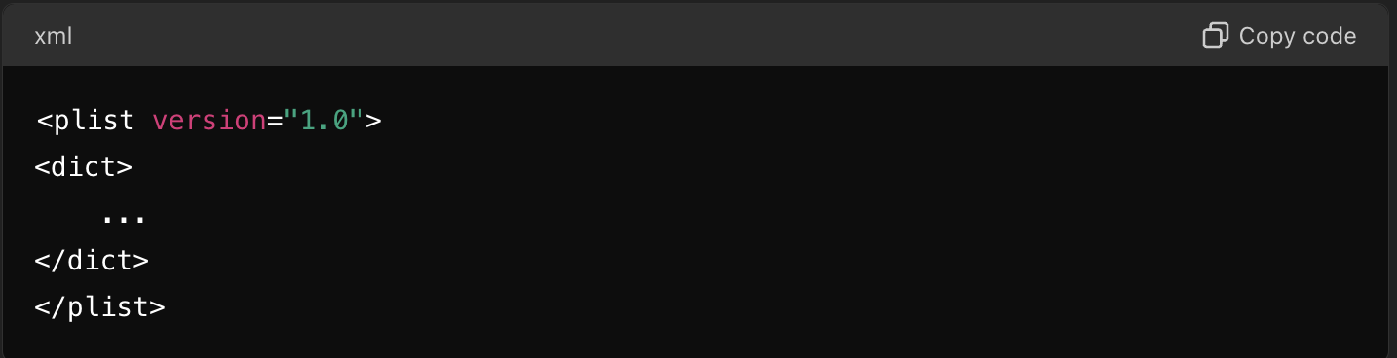  
  
The root element of the plist file is <plist>, and it contains a dictionary (<dict>) that holds key-value pairs.  
  
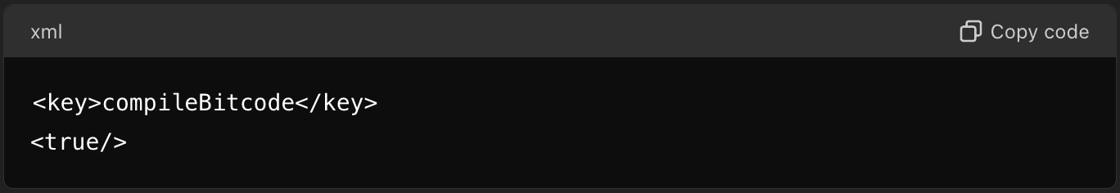  
  
This key indicates whether Bit code compilation is enabled. <true/> means it is enabled.

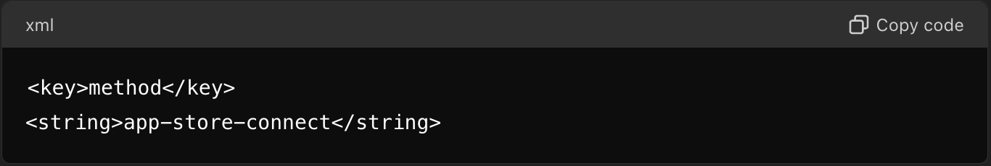  
  
This key specifies the method used for distribution. The value “app-store-connect” indicates the use of Apple’s App Store Connect.

Earlier the Method value was “app-store” [** DEPRECETED **].

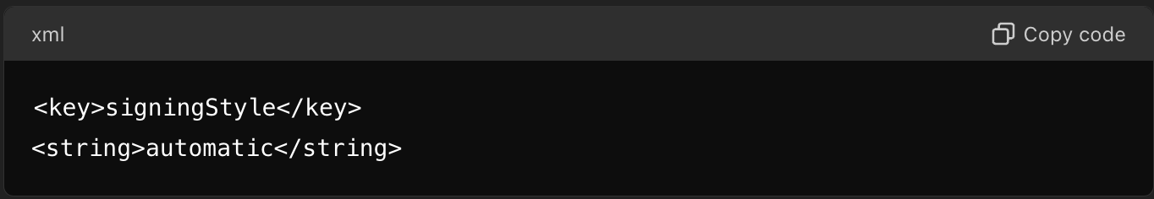

This key defines the signing style for the application. automatic means automatic signing is enabled and manual for manual signing.

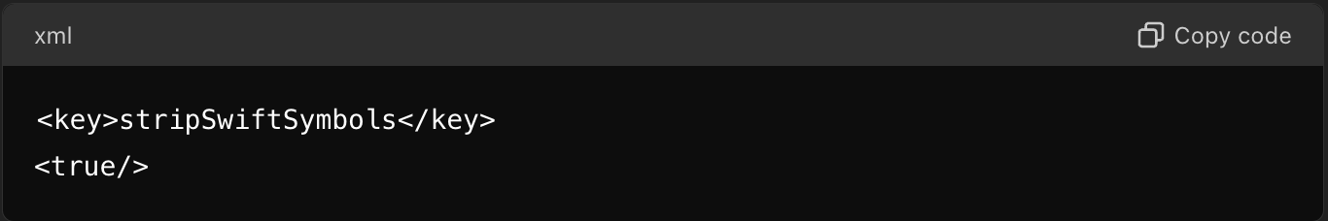

This key indicates whether Swift symbols should be stripped. <true/> means they should be stripped.  
  
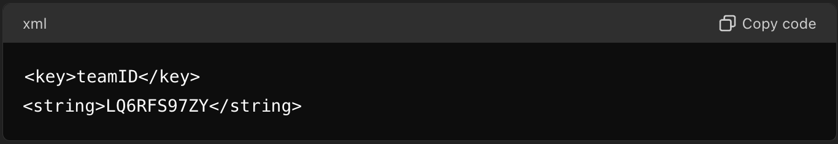  
  
This key specifies the team ID associated with the Apple Developer account. LQ6RFS97ZY is the team ID **[** Replace with your own Team ID **].**

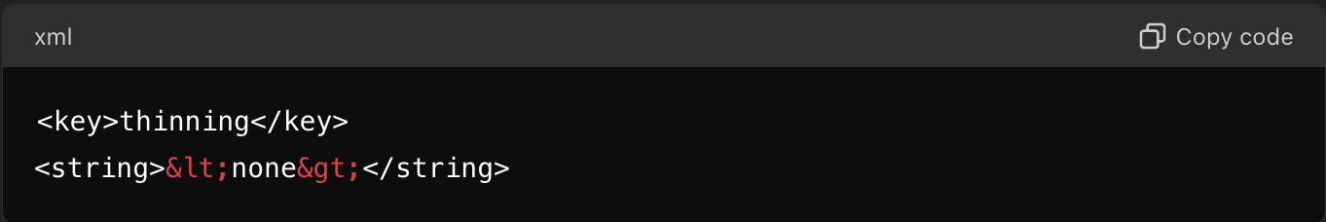  
  
This key indicates the thinning option used for app slicing. &lt;none&gt; (which translates to <none>) means no thinning is applied.

Now we have to test if everything is working as expected…  
  
Just Stage, Commit and Push all the changes to the Remote GitHub Repository the workflow will trigger automatically.  
 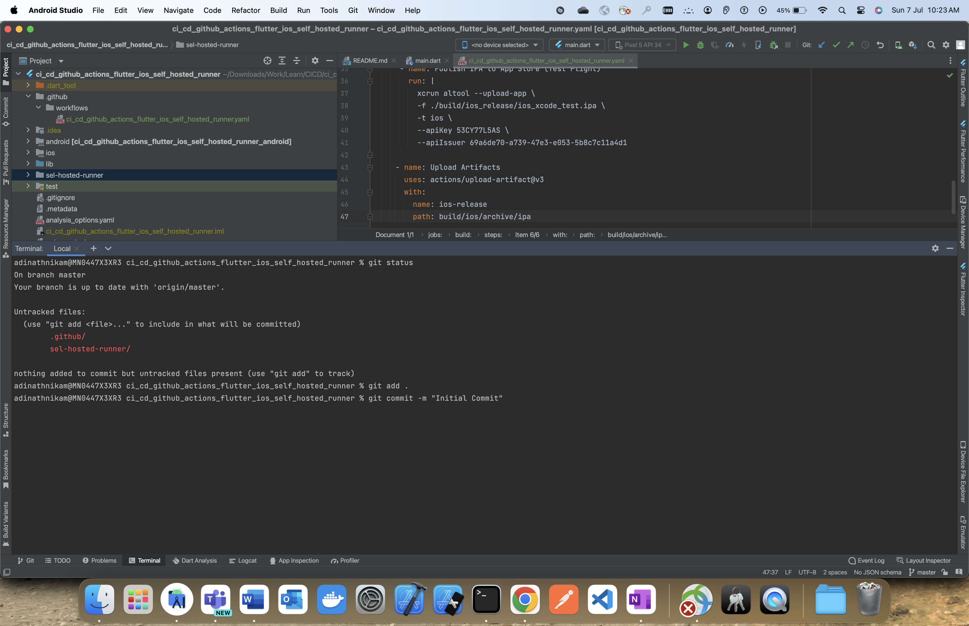

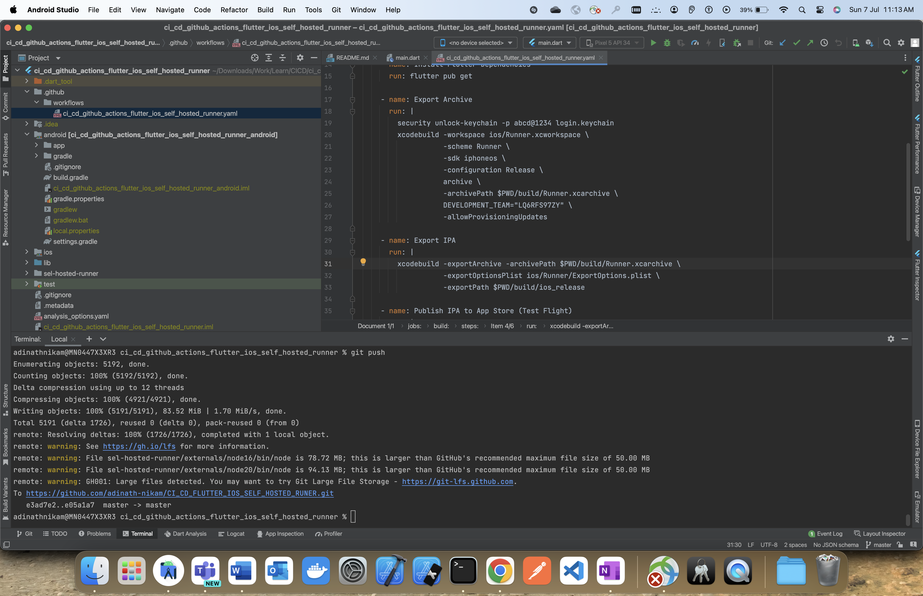

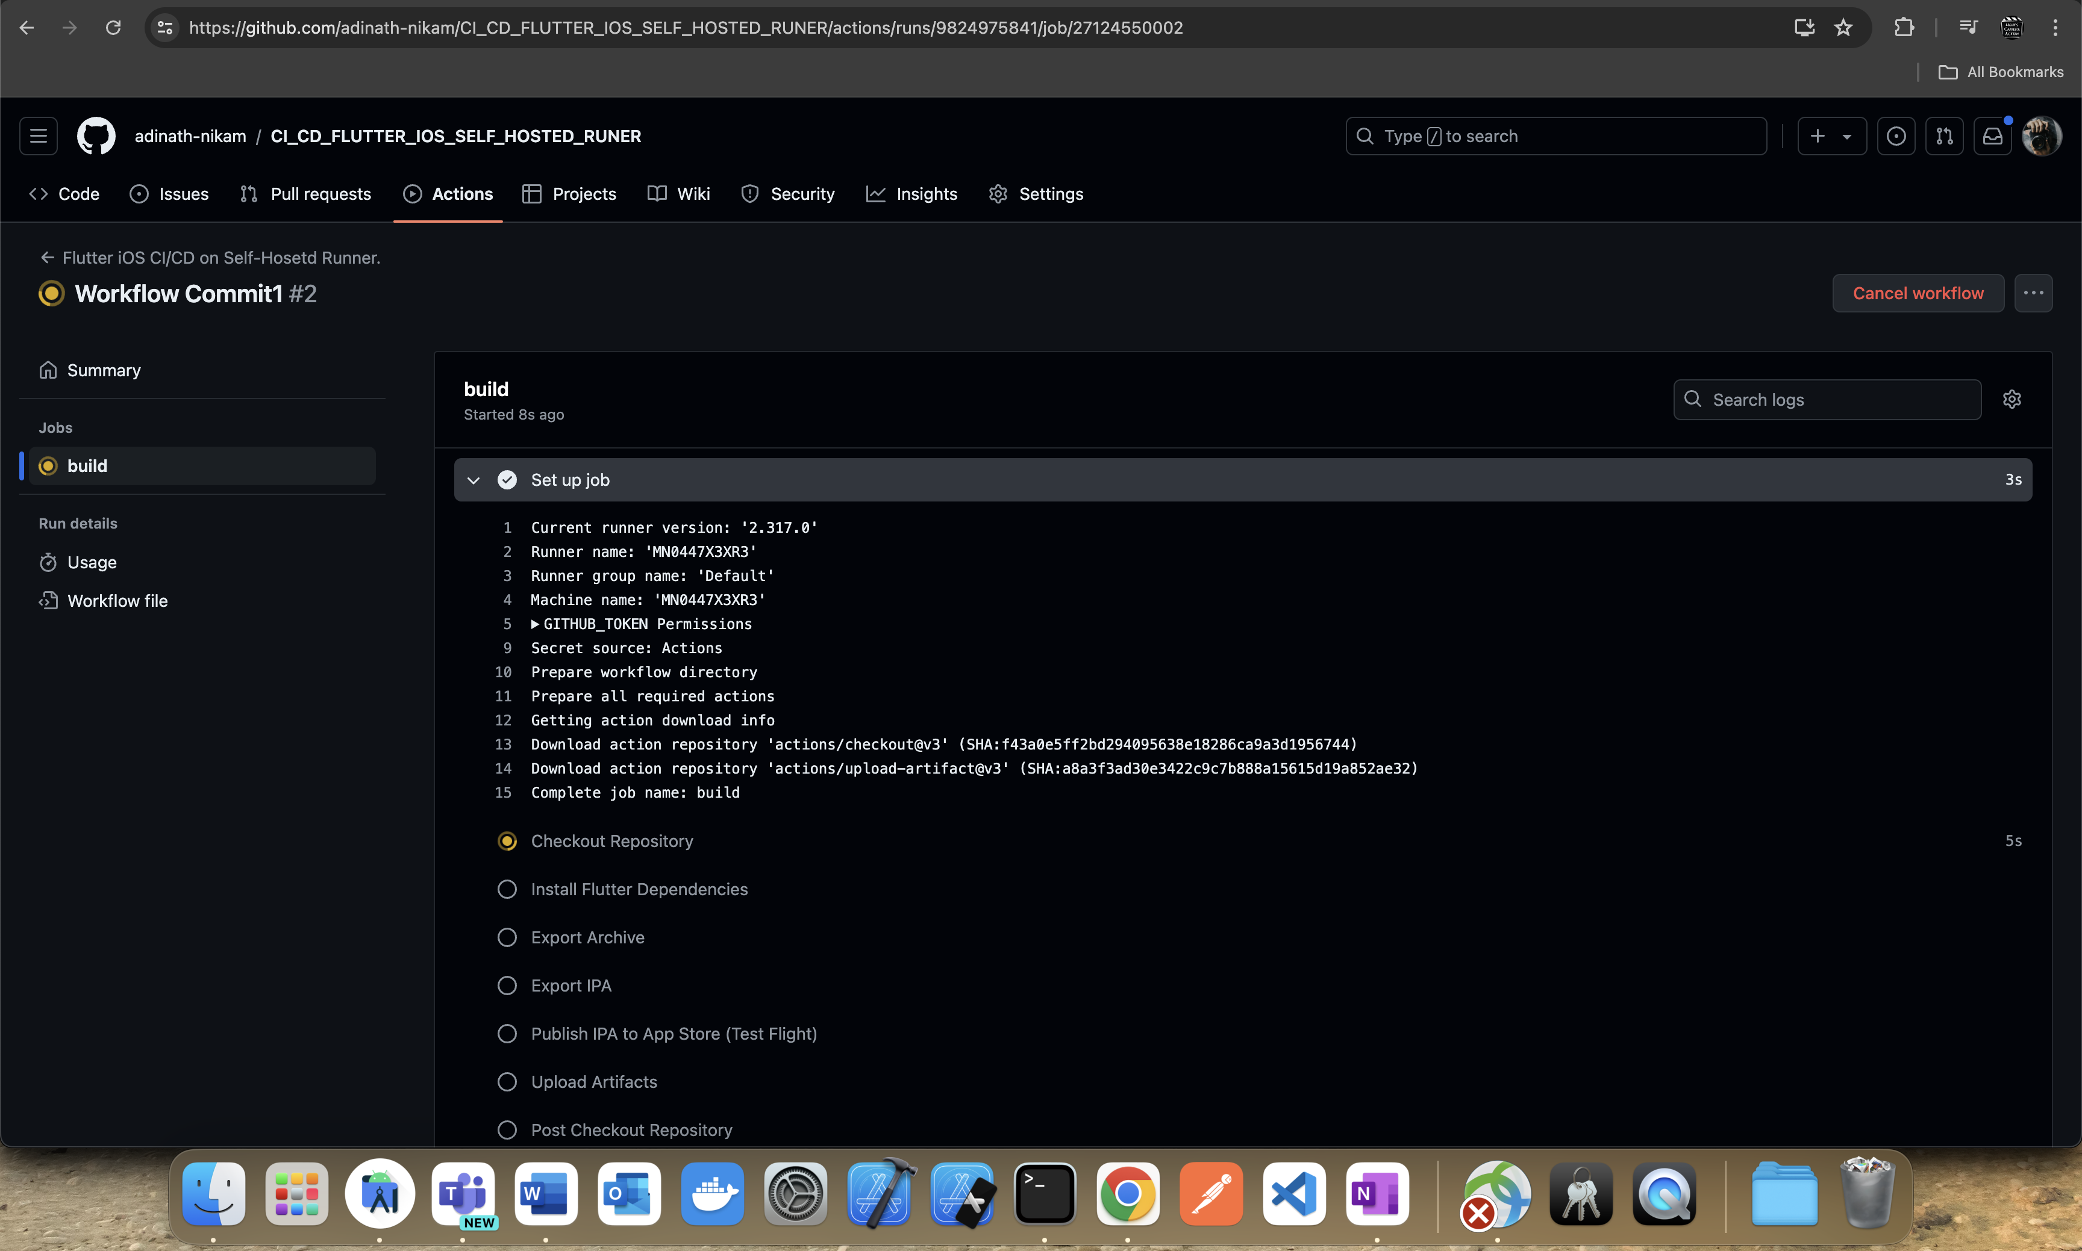

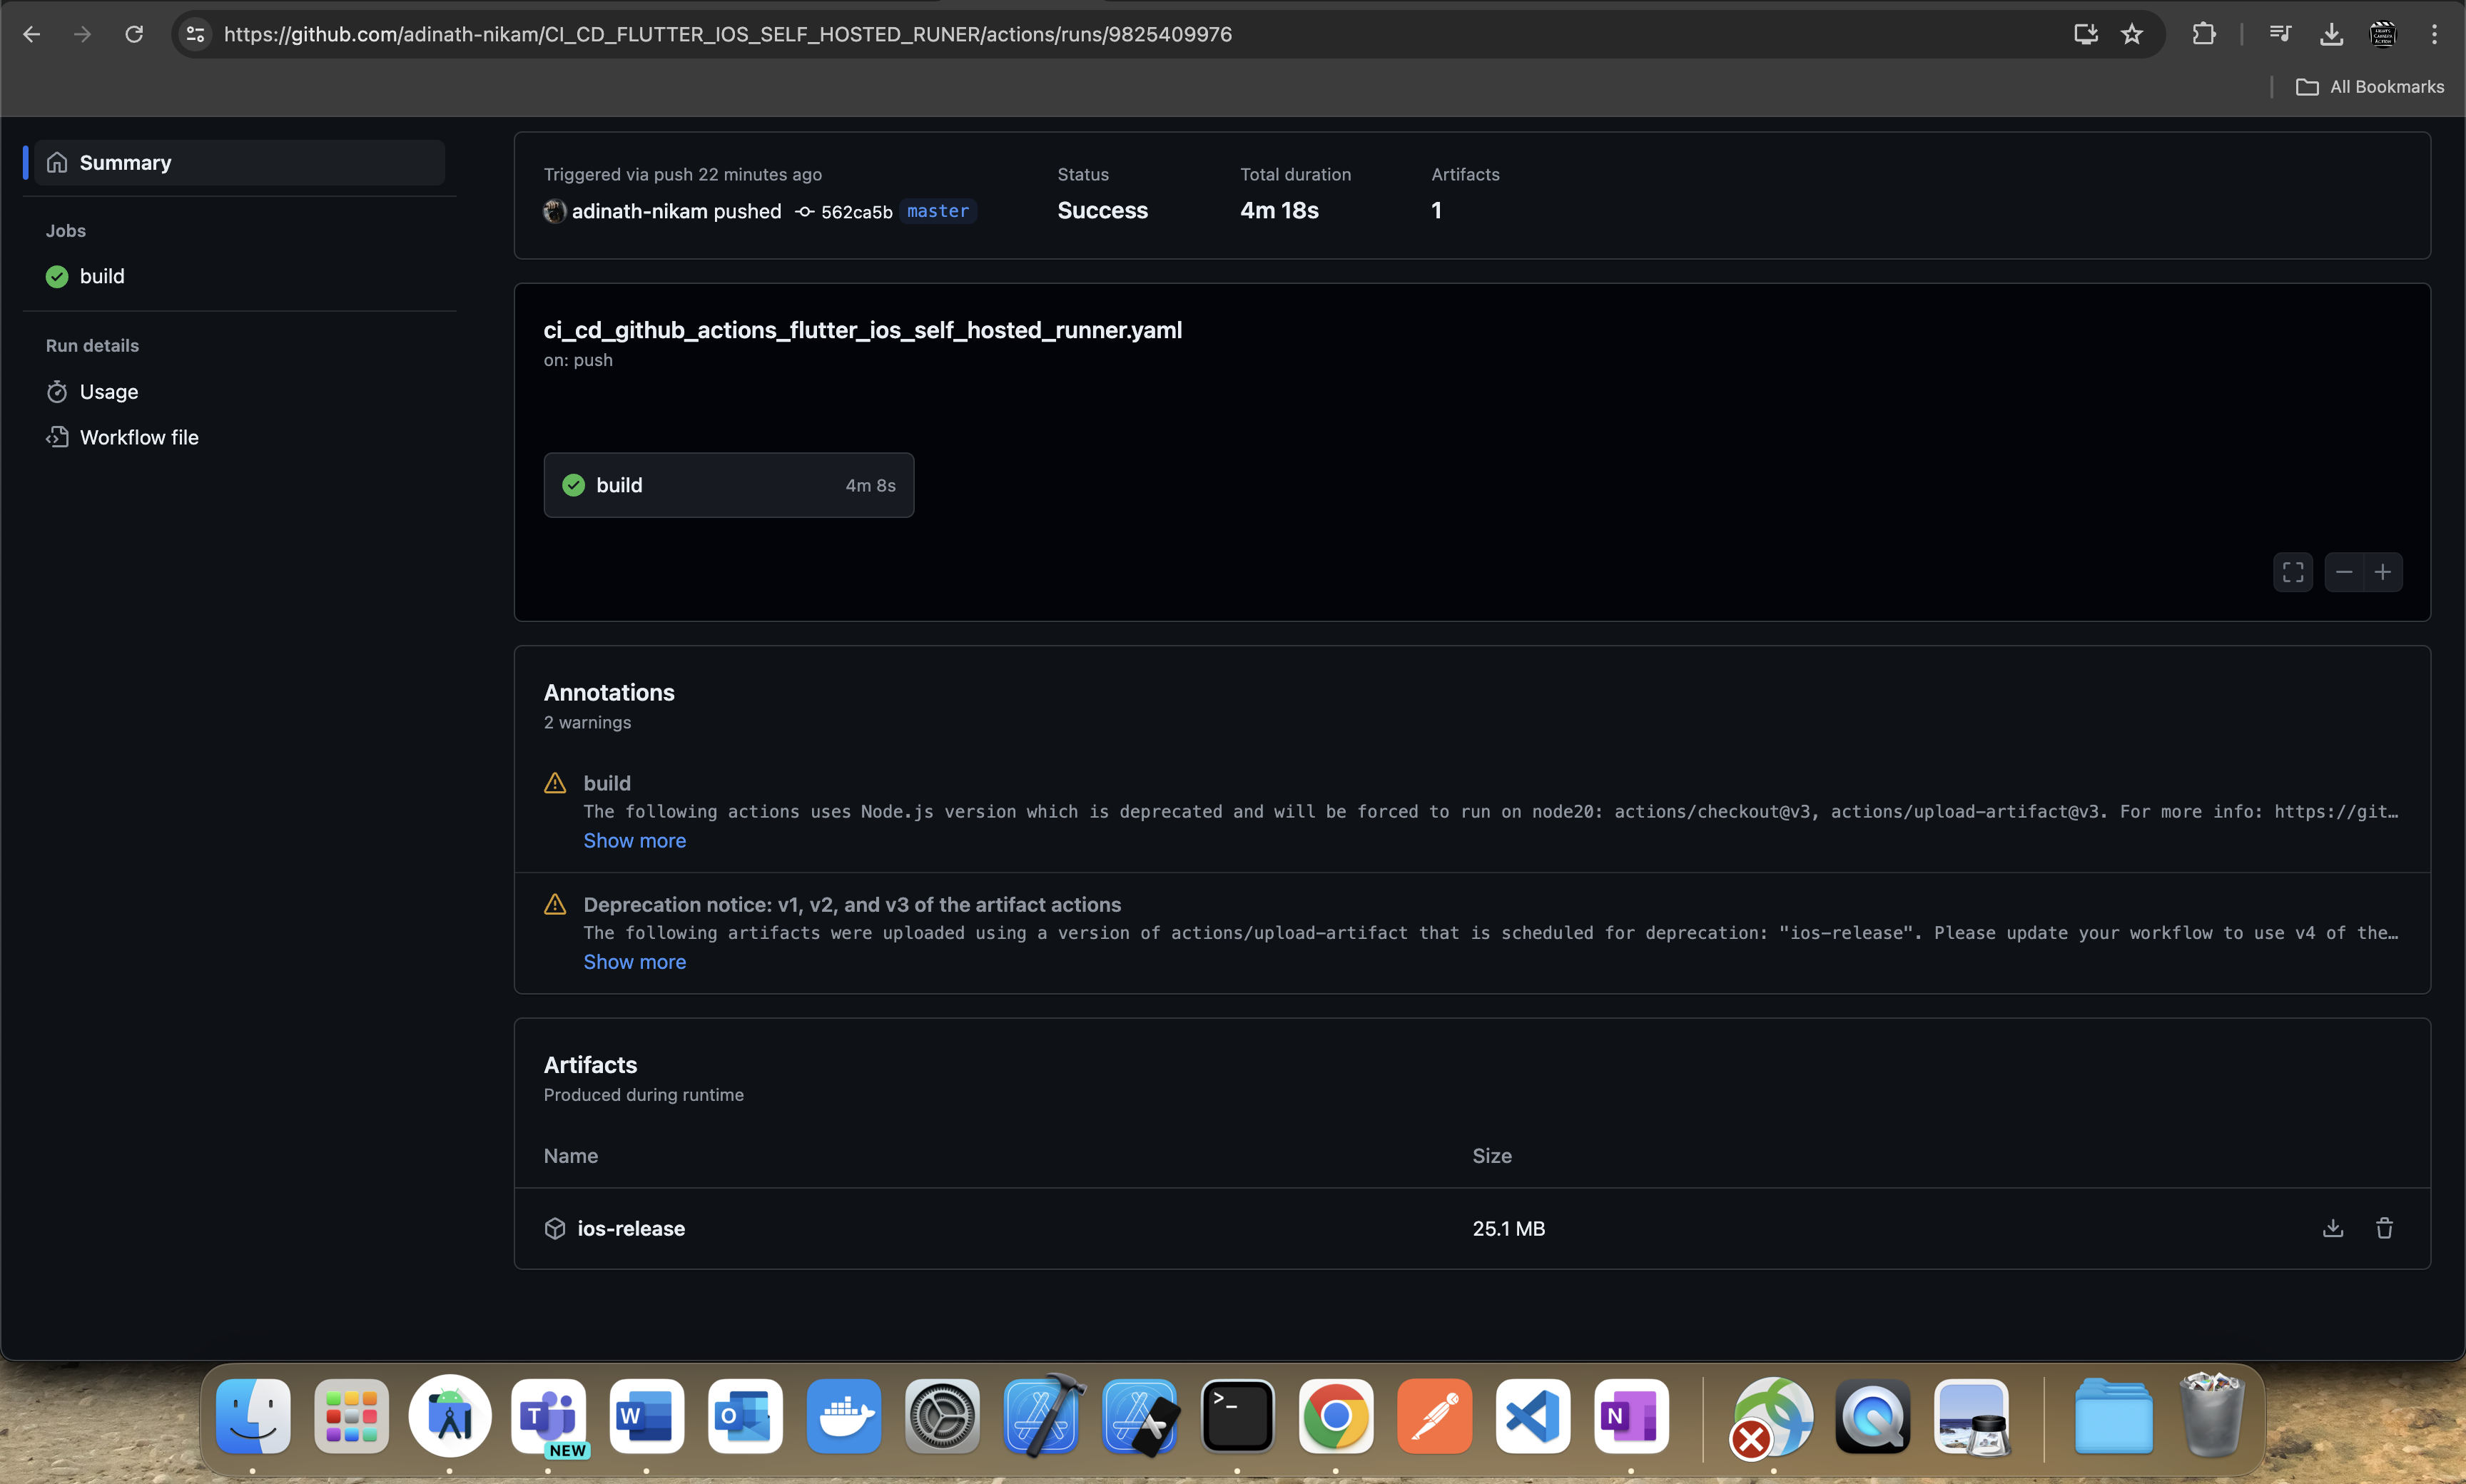

Navigate to GitHub Repository -> Actions and you’ll be able to see the Artifacts Appeared if everything has gone correct.